Practical - 3
Practical Title: Responsive UI Design using CSS Grid, Flexbox, and Bootstrap/Tailwind
Problem Definition: Design responsive layouts for Home, About, Registration, Dashboard, and Events pages using CSS Grid and Flexbox. Optional to use CSS framework such as Bootstrap or Tailwind. Ensure mobile-first responsiveness.

Theory

How does the layout adapt for mobile, tablet, and desktop screens?
Answer:
The layout uses responsive design with breakpoints to adjust content, navigation, and grids for mobile, tablet, and desktop screens.

Which layout technique is used and why?
Answer:
Bootstrap Grid (Flexbox) is used because it provides a responsive, flexible, and easy-to-manage layout.

Are typography, spacing, colors, and contrast readable?
Answer:
Yes, readable typography, proper spacing, suitable colors, and sufficient contrast improve accessibility and user experience.

Is the framework used consistently without unnecessary inline CSS?
Answer:
Yes, the framework classes are used consistently, and unnecessary inline CSS is avoided to keep the code clean and maintainable.

Implementation
• Used CSS Grid to create responsive page layouts.
• Applied Flexbox for navigation bars, forms, and content alignment.
• Followed a mobile-first approach using CSS media queries.
• Designed responsive layouts for Home, About, Registration, Dashboard, and Events pages.
• Used consistent typography, colors, spacing, and button styles.
• Added responsive navigation that adjusts for different screen sizes.
• Created flexible cards and sections that resize automatically.
• Ensured images and content scale properly on all devices.
• Maintained a clean and consistent design across all pages.

Evidence of Work (Screenshots)

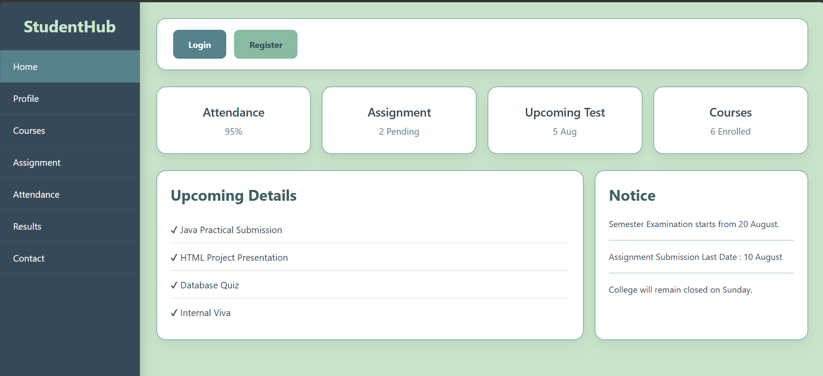
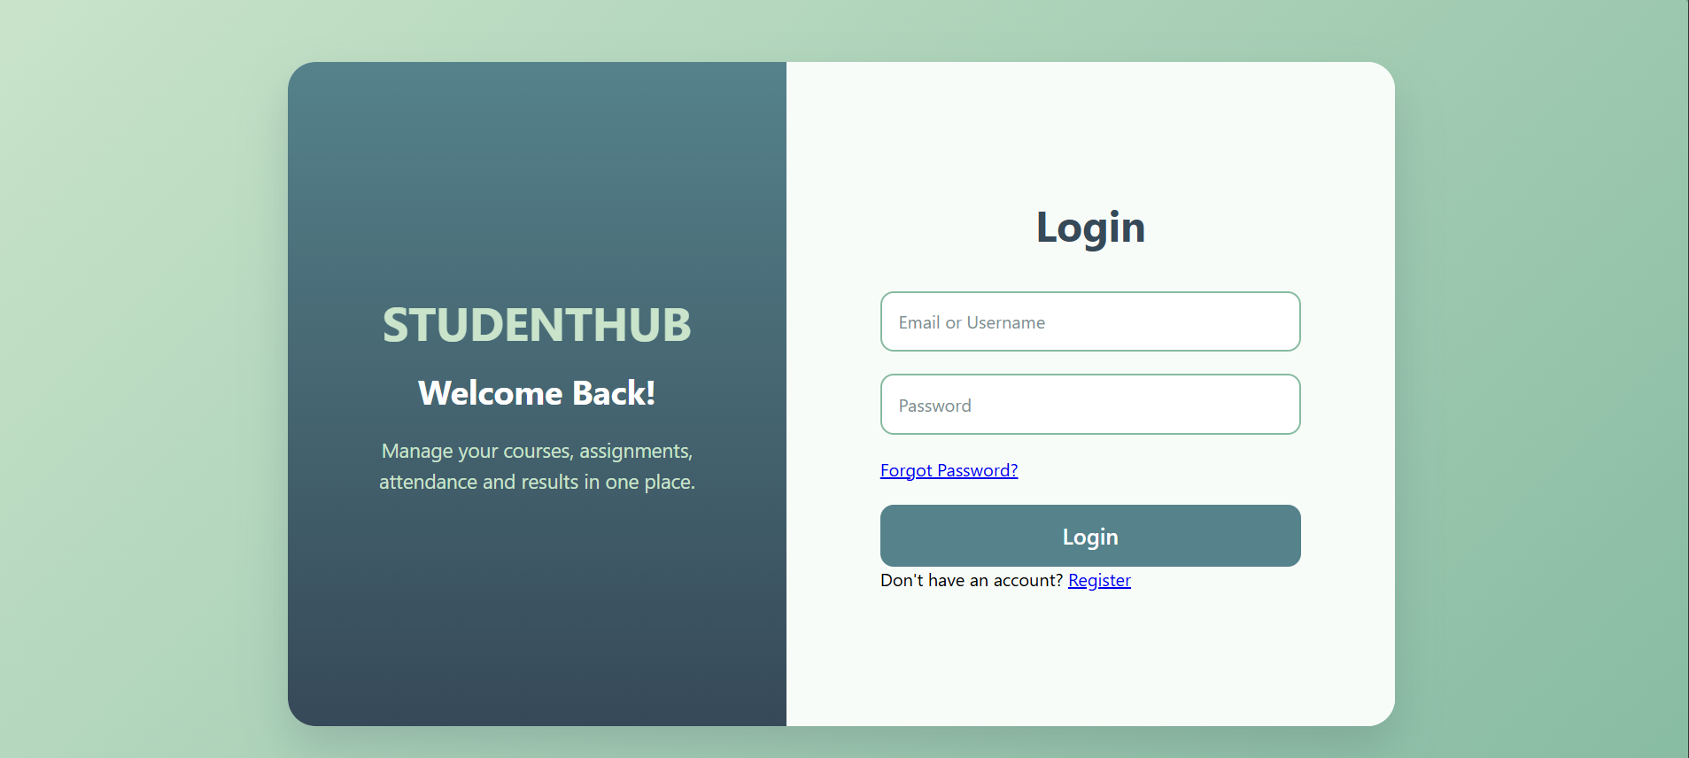

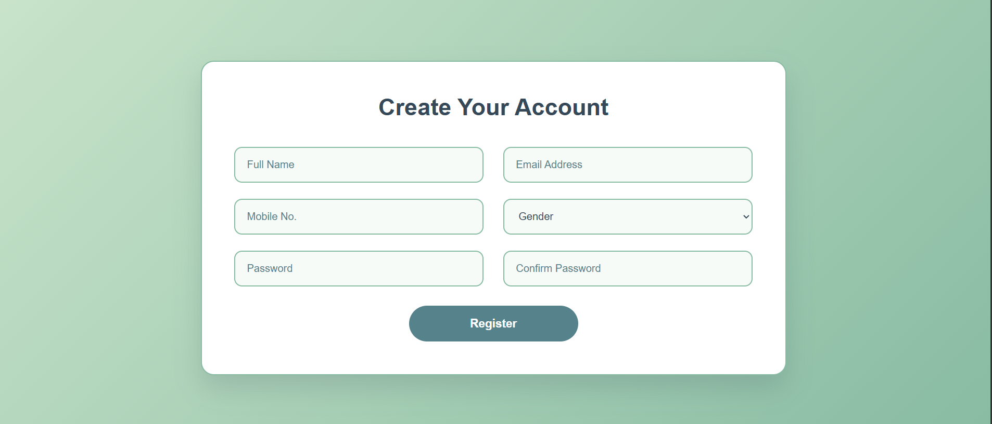
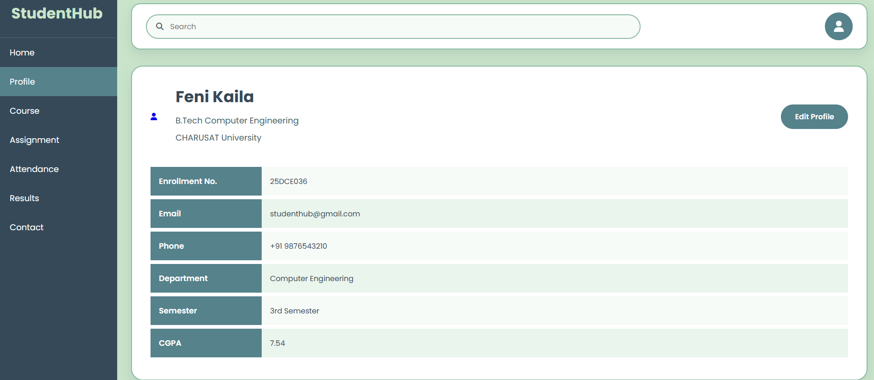
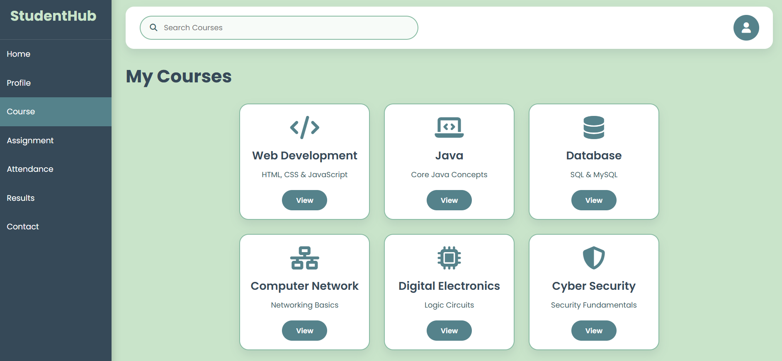

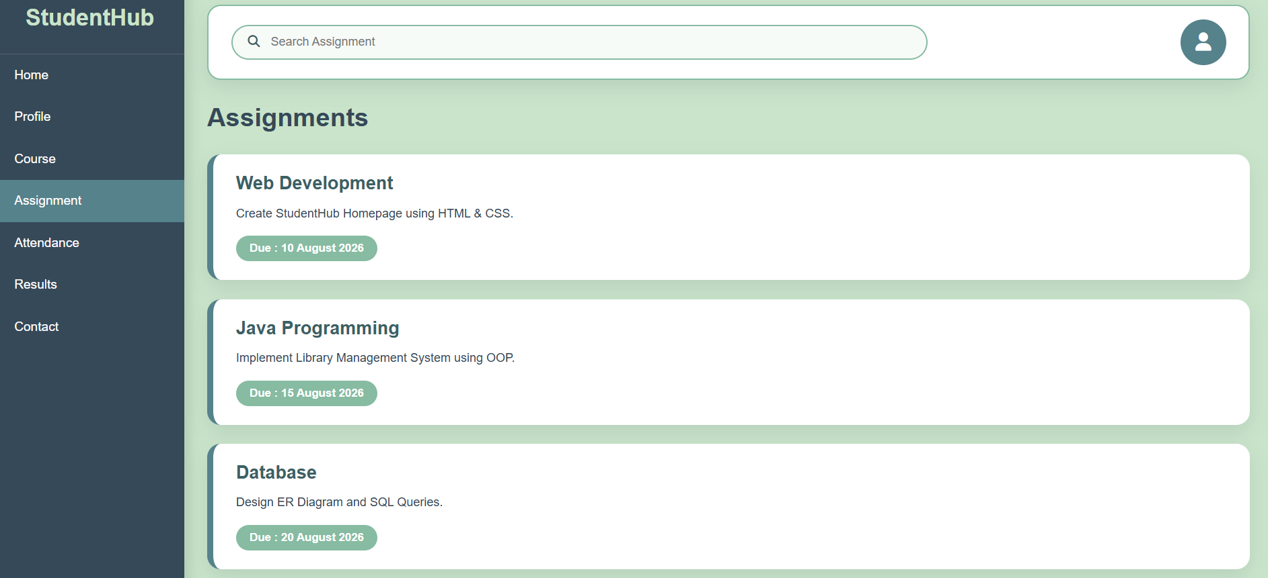
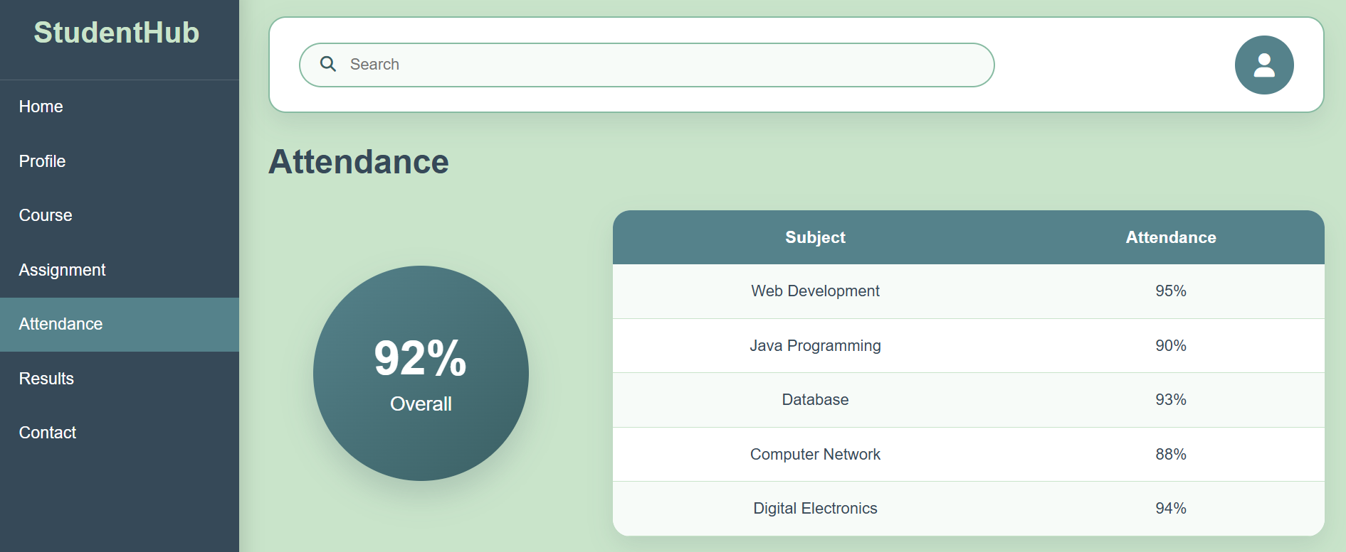
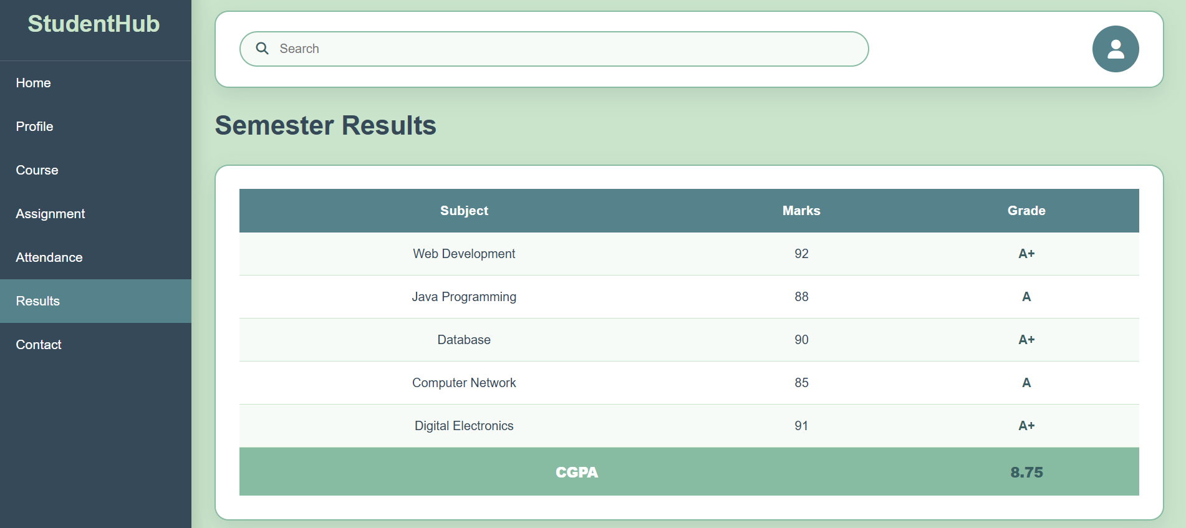

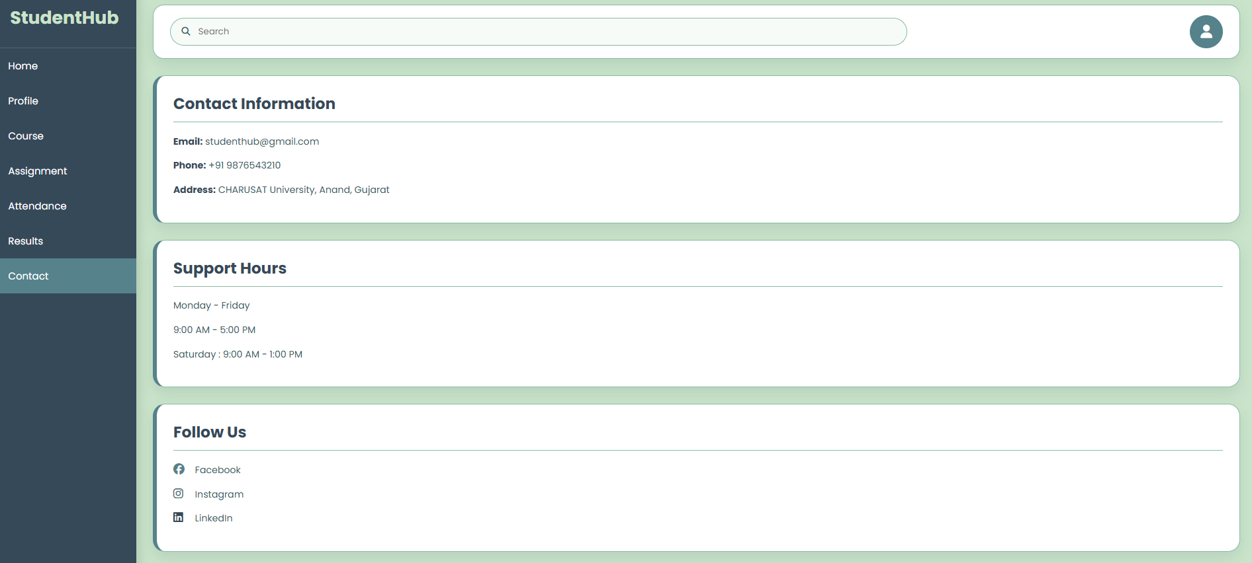

GitHub Repository Link:
https://github.com/fenikaila12/WDF/tree/main/Practical%203

Challenges Faced:
- Designing a mobile-first responsive layout.
- Using CSS Grid and Flexbox together effectively.
- Maintaining consistent alignment and spacing across pages.
- Ensuring compatibility with different screen sizes and devices.
- Keeping the design uniform and easy to maintain.

Learning Outcomes:
- Learned to create responsive web layouts using CSS Grid and Flexbox.
- Understood the mobile-first approach for web design.
- Improved skills in designing layouts for different screen sizes.
- Learned to maintain consistent styling and responsive navigation.
- Gained practical experience in building modern, user-friendly web pages.

Faculty Remarks: (Keep this blank for faculty)

